**Name: Hamza Mehmood Mughal**

**Intern ID: TN/IN02/PY/009**

**Task no:** **11**

**Question: Remove duplicates from list**

**Find intersection of two sets.**

Code:

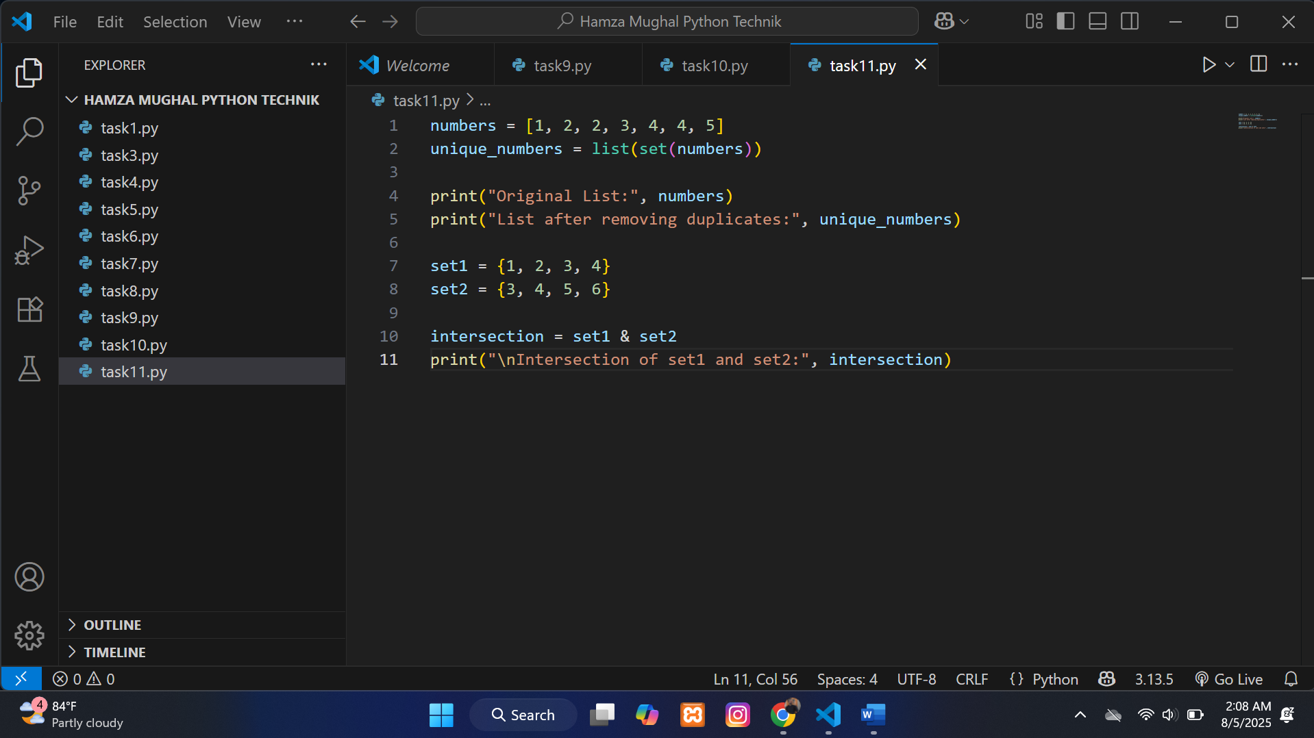

**Output:**

